Report I

Name: Obarijima Obele

Name of Lecturer: Szczepan Paszkiel

Subject: Internet Technologies

Academic Year: 2024/2025

Date: October 15, 2024

# Table of Contents

1. Introduction

2. CSS Classes

3. Outbound and Inbound Links

4. Image Gallery Creation

5. HTML & CSS Validation

6. Website URL

7. Website screenshots

# 1. Introduction

This report provides an overview of my web development project, highlighting key features such as CSS usage, linking structure, image gallery creation, and validation processes.

# 2. CSS Classes

In this project, I used CSS classes to style various elements of the website, such as the navigation bar, buttons, and image gallery. For example, the '.gallery-item' class formats each image block by applying a shadow effect, margin, and hover animation, while the '.description' class aligns text beneath each image. This consistent styling ensures a clean, unified look across all elements.

.gallery-item {  
 border-radius: 10px;  
 overflow: hidden;  
 box-shadow: 0 4px 10px rgba(0, 0, 0, 0.1);  
 transition: transform 0.3s ease;  
 }  
  
 .gallery-item:hover {  
 transform: scale(1.05);  
 }  
  
 .description {  
 text-align: center;  
 background-color: rgba(0, 0, 0, 0.5);  
 color: white;  
 padding: 10px;  
 }

# 3. Outbound and Inbound Links

The website contains several outbound links in the Resources section, directing users to external websites such as Airbnb, Expedia, Booking.com etc. The inbound links, such as the 'Gallery' and 'Resources' links in the navigation bar, facilitate easy navigation between different sections of the site.

<!-- Inbound Links -->  
 <ul class="nav">  
 <li><a href="index.html">Home</a></li>  
 <li><a href="gallery.html">Gallery</a></li>  
 </ul>  
  
 <!-- Outbound Links in Resources section -->

<!-- Outbound Links in Resources section -->

<p>Useful travel and accommodation resources:</p>

<ul>

<li><a href="https://www.booking.com" target="_blank">Booking.com</a> - Find great deals on hotels, apartments, and more.</li>

<li><a href="https://www.expedia.com" target="_blank">Expedia</a> - Book flights, hotels, vacation packages, and car rentals.</li>

<li><a href="https://www.airbnb.com" target="_blank">Airbnb</a> - Discover unique stays and experiences around the world.</li>

</ul>

# 4. Image Gallery Creation

The image gallery was created using HTML and CSS, utilizing the 'flexbox' layout to arrange the images into responsive rows. If there are too many images for a single row, they wrap onto the next line. Each gallery item is enclosed within a '.gallery-item' div. The hover effect enhances user experience by slightly enlarging the image when hovered over.

# <section class="gallery"> <div class="gallery-item"> <a href="images/photo1.jpg" target="_blank"> <img src="images/photo1.jpg" alt="City 1" /> </a> <div class="description">City 1 - Beautiful skyline</div> </div> </section> .gallery { display: flex; flex-wrap: wrap; gap: 20px; } .gallery-item img { width: 100%; transition: transform 0.3s ease; } .gallery-item:hover img { transform: scale(1.05); } 5. HTML & CSS Validation

I validated both the HTML and CSS files using the W3C Validator (http://validator.w3.org/). This process helped ensure that the code follows web standards and is free of errors or warnings. Any issues encountered were promptly fixed to maintain high-quality code.

# 6. Website URL

[My Website LINK](https://purple-sindee-97.tiiny.site/index.html)

# 7. Website Screenshots

Home page

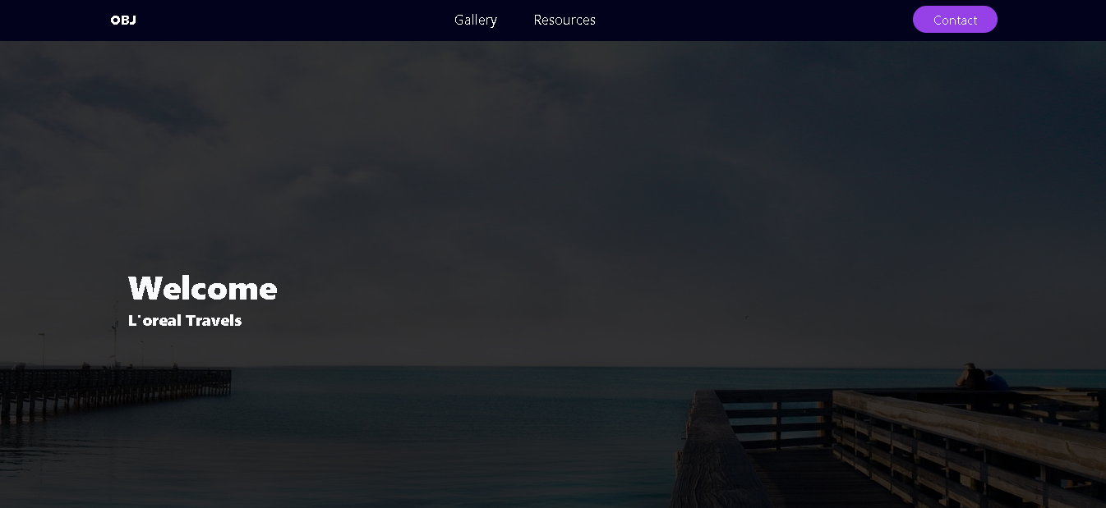

Gallery

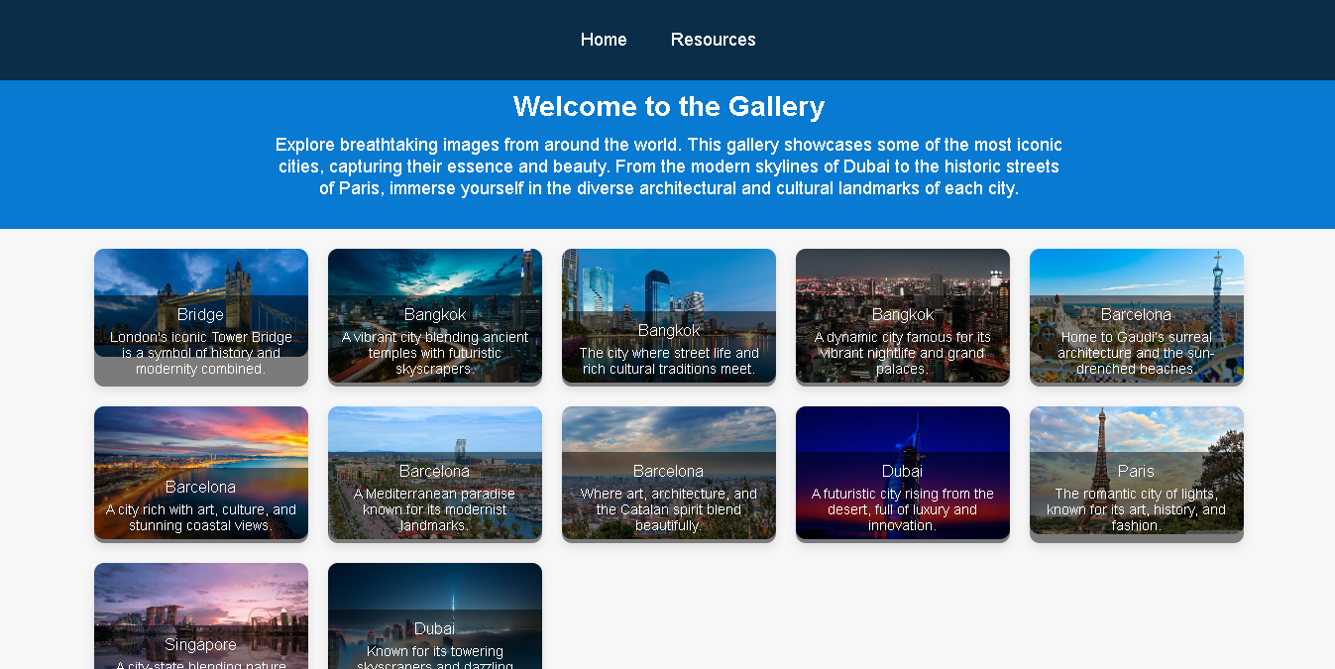

Resources

